**AMERICAN INTERNATIONAL**

**UNIVERSITY-BANGLADESH**

408/1, Kuratoli, Khilkhet, Dhaka 1229, Bangladesh

Title: Familiarization with microcontroller, study of blink test using and implementation of a traffic control system using microcontrollers

|  |  |  |
| --- | --- | --- |
| **Lab report no:** 01 |  | **Date of Submission:** 25-09-2023 |
| **Course Title:** Microprocessor & Embedded System |  |  |
| Course Code: |  | **Section:** L |
| **Semester:** 09 | 2023-24 | **Course Teacher:** PROTIK PARVEZ SHEIKH |

**Declaration and Statement of Authorship:**

1. I/we hold a copy of this Assignment/Case-Study, which can be produced if the original is lost/damaged.
2. This Assignment/Case-Study is my/our original work and no part of it has been copied from any other student’s work or from any other source except where due acknowledgement is made.
3. No part of this Assignment/Case-Study has been written for me/us by any other person except where such collaborationhas been authorized by the concerned teacher and is clearly acknowledged in the assignment.
4. I/we have not previously submitted or currently submitting this work for any other course/unit.
5. This work may be reproduced, communicated, compared and archived for the purpose of detecting plagiarism.
6. I/we give permission for a copy of my/our marked work to be retained by the Faculty for review and comparison, including review by external examiners.

*\* Student(s) must complete all details except the faculty use part.*

** Please submit all assignments to your course teacher or the office of the concerned teacher.

Group Name

/

No.

:

|  |  |  |  |  |
| --- | --- | --- | --- | --- |
| **No** | **Name** | **ID** | **Program** | **Signature** |
| 1 | NOKIBUL ARFIN SIAM | 21-44793-1 | CSE | Siam |
| 2 | MD. IMRAN AHMED | 20-43738-2 | CSE | Imran |
| 3 | TANVIR HASAN TAMAL | 21-44626-1 | CSE | Tamal |
| 4 | TAZUDDIN AHMAD | 20-42787-1 | CSE | Tazuddin |
| 5 | MD. ZAMIUL SADIK NAHIN | 20-44228-3 | CSE | Nahin |

|  |  |  |
| --- | --- | --- |
| ***Faculty use only*** |  | |
| FACULTYCOMMENTS | **Marks Obtained** |  |
|  |
|  |
|  | **Total Marks** |  |
|  |
|  |

Assignment/Case-Study Cover; © AIUB-2020

Title: Familiarization with microcontroller, study of blink test using and implementation of a traffic control system using microcontrollers

**Introduction:**

The objectives of this experiment are to-

1. Get familiar with Arduino microcontrollers.

2. Use an Arduino and delay functions to make an LED blink.

3. Implement an LED traffic control system using Arduino.

4. Simulate the microcontroller-based systems using proteus.

**Equipment List:**

1. Arduino IDE (2.0.1 or any recent version)
2. Arduino Microcontroller board
3. Bread board
4. LED lights (Red, Green, and Yellow)
5. Three 200 Ω resistors
6. Jumper wires

**Circuit diagram:**

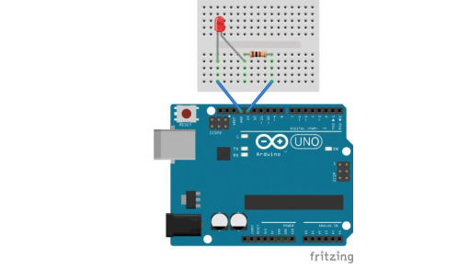

***Fig-1:*** *LED Blink Test using an Arduino Microcontroller Board*

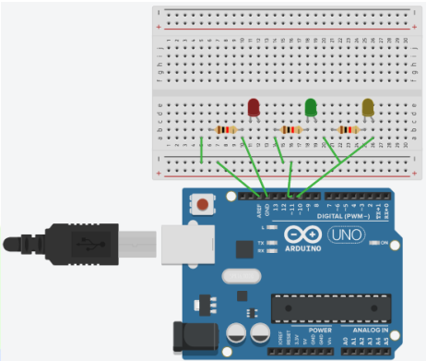

***Fig-2:*** *Traffic Control System using an Arduino Microcontroller Board*

**Code/program:**

|  |
| --- |
| **LED Blink** |
| int led=13; void setup () {   pinMode(led, OUTPUT);   }    void loop () {     digitalWrite (led, HIGH);     delay (1000);     digitalWrite (led, LOW);     delay (1000);   } |

|  |
| --- |
| **Traffic Control System** |
| #define RED_PIN 8 #define YELLOW_PIN 10 #define GREEN_PIN 12 int red_on = 3000; int red_yellow_on = 1000; int green_on = 3000; int green_blink = 500; int yellow_on = 1000; void setup() { pinMode(RED_PIN, OUTPUT); pinMode(YELLOW_PIN, OUTPUT); pinMode(GREEN_PIN, OUTPUT); } void loop() {  digitalWrite(RED_PIN, HIGH); //to make red LED on delay(red_on); //to turn yellow LED on digitalWrite(YELLOW_PIN, HIGH); delay(red_yellow_on);    //turning off RED_PIN and YELLOW_PIN, and turrning on greenLEd digitalWrite(RED_PIN, LOW); digitalWrite(YELLOW_PIN, LOW); digitalWrite(GREEN_PIN, HIGH); delay(green_on); digitalWrite(GREEN_PIN, LOW);    //for turning green Led on and off for 3 times for(int i = 0; i < 3; i = i+1) { delay(green_blink); digitalWrite(GREEN_PIN, HIGH); delay(green_blink); digitalWrite(GREEN_PIN, LOW); } //for turning on yellow LED digitalWrite(YELLOW_PIN, HIGH); delay(yellow_on); digitalWrite(YELLOW_PIN, LOW); } |

**Hardware Implementation:**

**LED Blink Test**

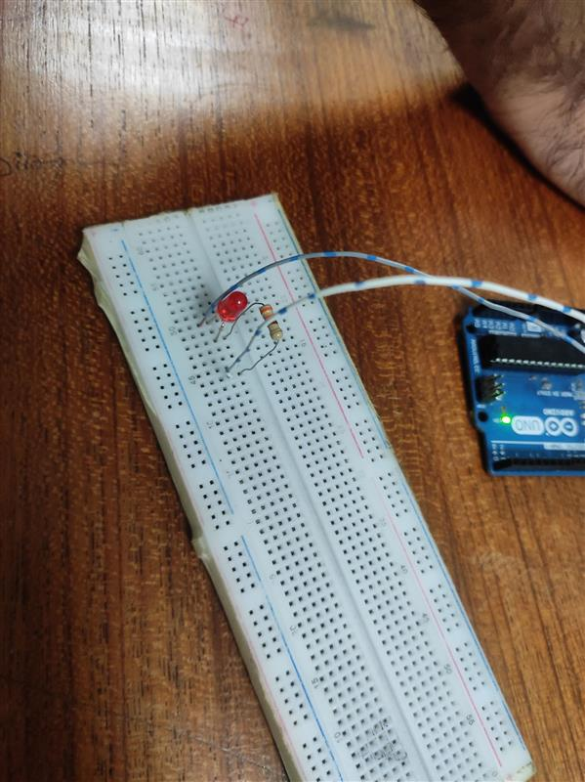

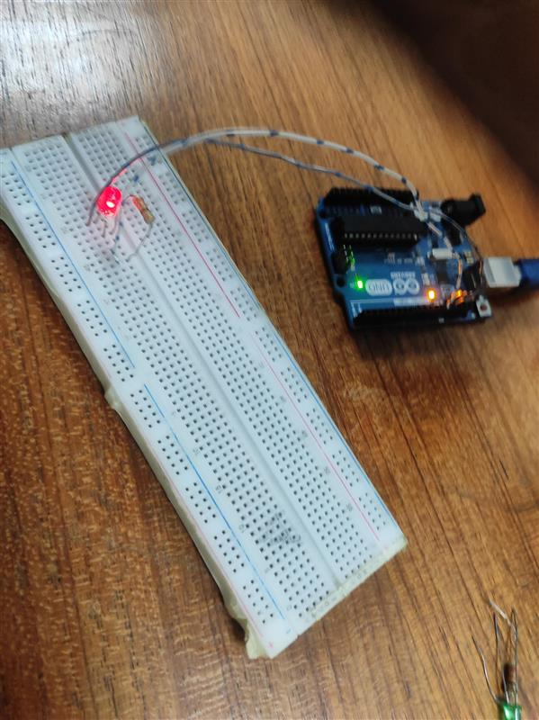

**Traffic Control System**

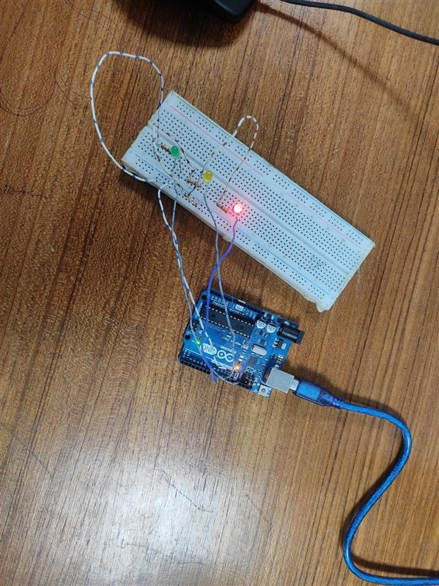

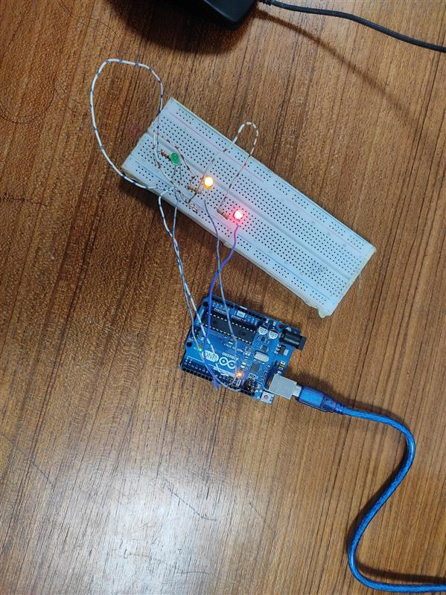

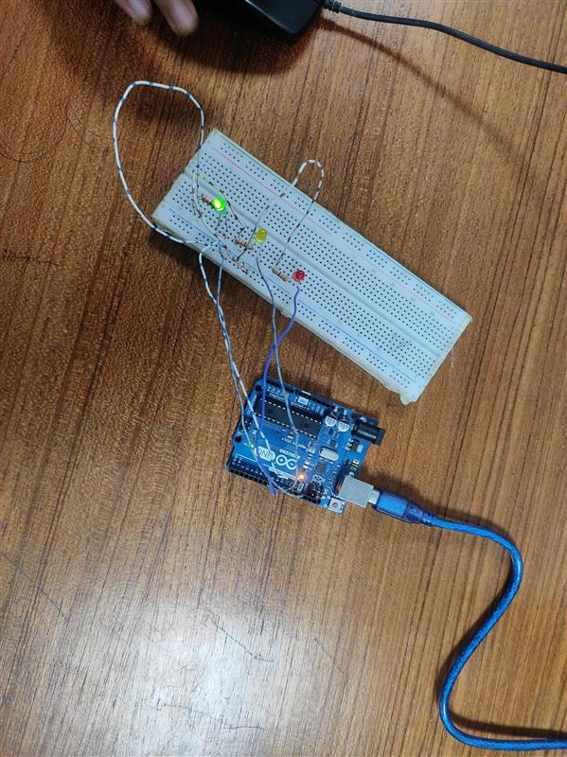

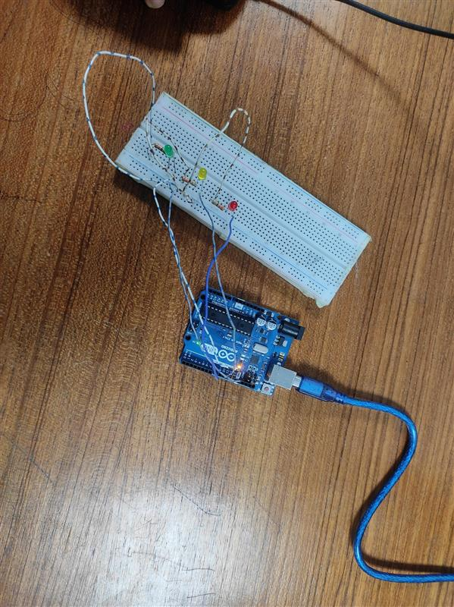

**Simulation:**

**LED blink**

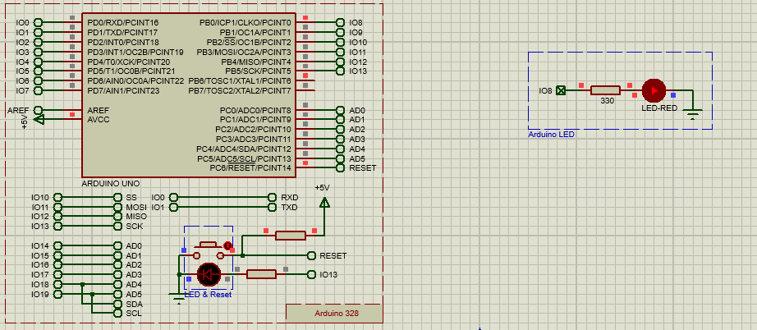

**Traffic Light**

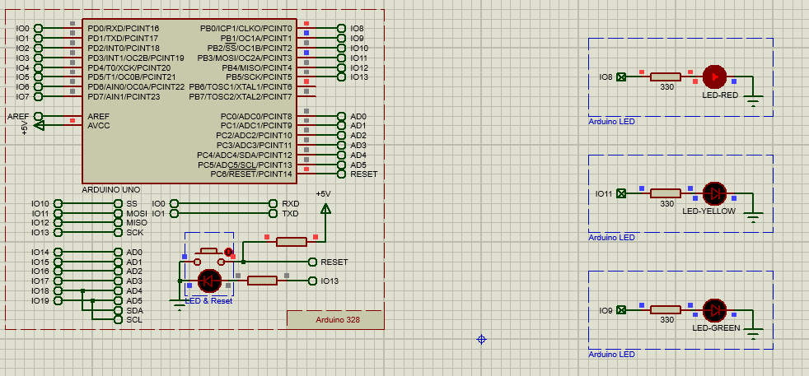

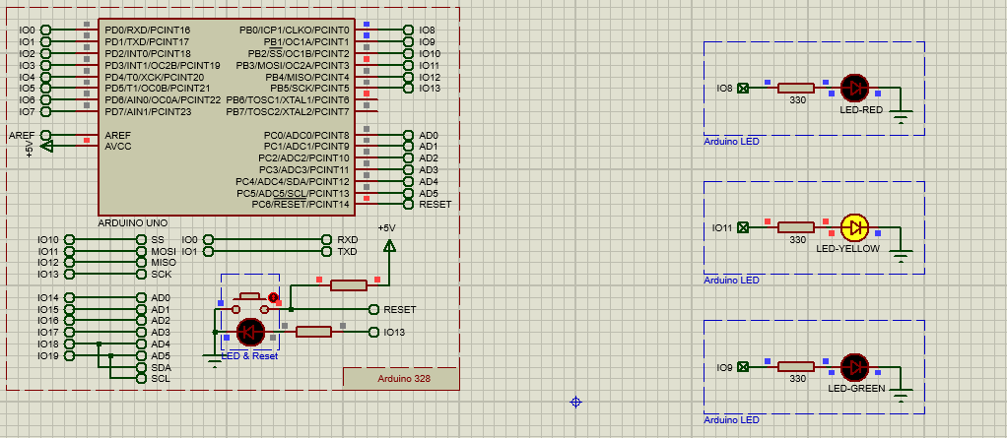

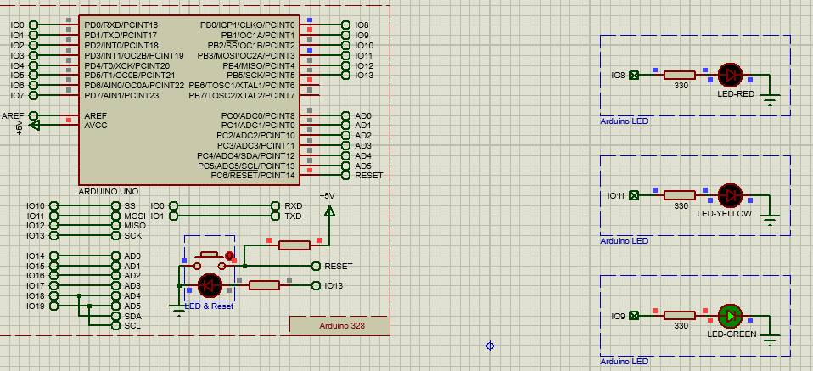

**Flowchart**

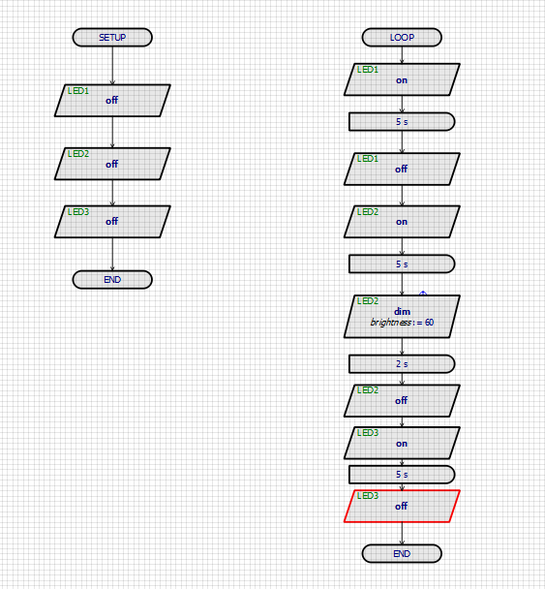

**Discussion:** The purpose of the experiment was to gain experience with the Arduino IDE software and to create an LED blink using the Arduino platform and its delay functions. Additionally, a traffic control system was built using the Arduino microcontroller. To begin, the code was written in the IDE software and tested on a breadboard circuit. Once confirmed, the code was then transferred to the Arduino board. The experiment was successfully completed without any hardware or code-related issues and produced similar results both in simulation and in real-life testing.

**Reference(s):**

1) https://www.arduino.cc/.

2) https://www.coursera.org/learn/arduino/lecture/ei4ni/1-10-first-glance-at-a-program

3) Jeremy Blue; Exploring Arduino: Tools and Techniques for Engineering Wizardry